**R Code for Examples in the book**

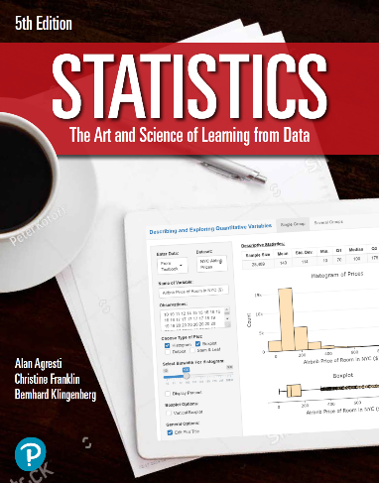

***“Statistics: The Art and Science of Learning from Data”***

**by Agresti, Franklin and Klingenberg, 5th edition**

**Chapter 2**

**Example 19: Women’s Heptathlon – Standardizing**

## Reading in the data of the performances of athletes:

meters200 <- c(24.48, 23.49, 23.26, 24.32, 24.09, 24.67)  
javelin <- c(39.39, 46.06, 36.36, 37.77, 40.93, 33.42)

## To compute the z-scores of each athlete for both events:

zScoresMeters200 <- (meters200 - mean(meters200)) / sd(meters200)  
zScoresJavelin <- (javelin - mean(javelin)) / sd(javelin)

## Rounding z scores to 2 decimal places

round(zScoresMeters200, 2)

## [1] 0.76 -1.00 -1.41 0.48 0.07 1.10

round(zScoresJavelin, 2)

## [1] 0.09 1.64 -0.61 -0.28 0.45 -1.29